Number System Conversions
A number system is a system representing numbers. It is also called the system of numeration and it defines a set of values to represent a quantity. These numbers are used as digits and the most common ones are 0 and 1, that are used to represent binary numbers. Digits from 0 to 9 are used to represent other types of number systems.

Types of Number Systems
There are different types of number systems in which the four main types are:
- Binary number system (Base - 2)
- Octal number system (Base - 8)
- Decimal number system (Base - 10)
- Hexadecimal number system (Base - 16)

Number System Chart
Given below is a chart of the main four types of number system that we use to represent numbers.
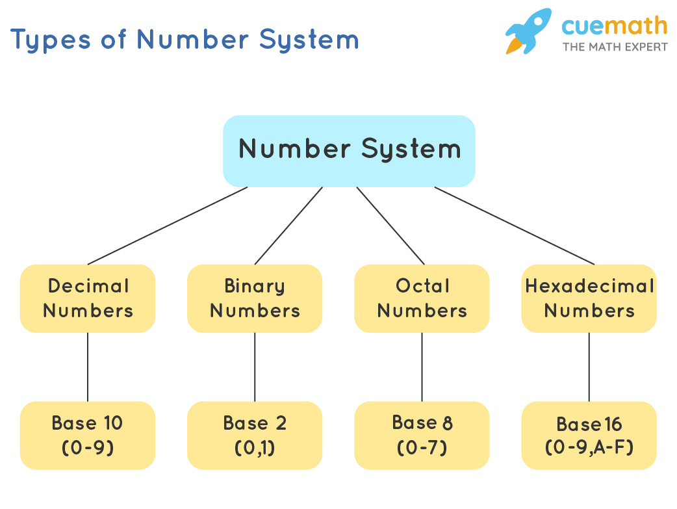

Binary Number System
The binary number system uses only two digits: 0 and 1. The numbers in this system have a base of 2. For example: 10001₂, 111101₂, 1010101₂ are some examples of numbers in the binary number system.
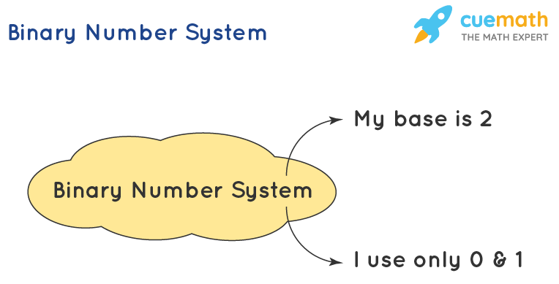

Octal Number System
The octal number system uses eight digits: 0,1,2,3,4,5,6 and 7 with the base of 8. For example: 35₈, 23₈, 141₈ are some examples of numbers in the octal number system.
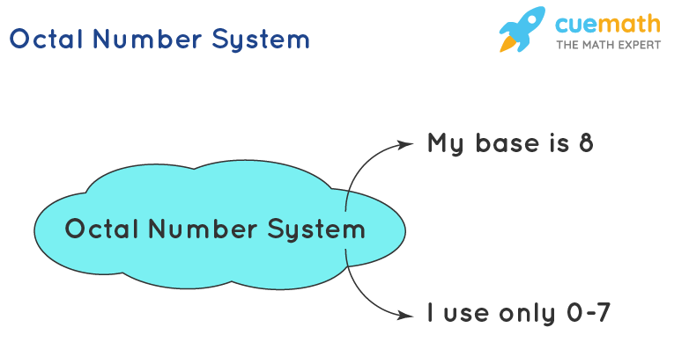

Decimal Number System
The decimal number system uses ten digits: 0,1,2,3,4,5,6,7,8 and 9 with the base number as 10. The decimal number system is the system that we generally use to represent numbers in real life. If any number is represented without a base, it means that its base is 10. For example: 723₁₀, 32₁₀, 4257₁₀ are some examples of numbers in the decimal number system.
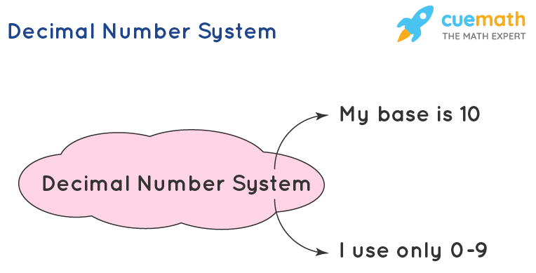

Hexadecimal Number System
The hexadecimal number system uses sixteen digits/alphabets: 0,1,2,3,4,5,6,7,8,9 and A,B,C,D,E,F with the base number as 16. Here, A-F of the hexadecimal system means the numbers 10-15 of the decimal number system respectively. For example: 7B3₁₆, 6F₁₆, 4B2A₁₆ are some examples of numbers in the hexadecimal number system.
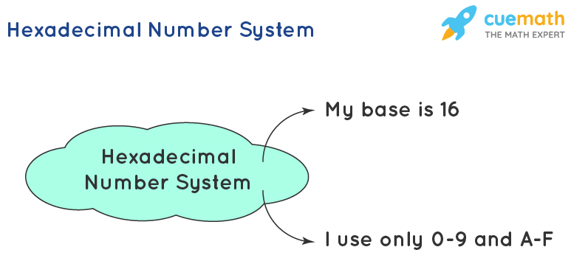
Conversions

Decimal to Binary
Decimal numbers can be converted to binary by repeated division of the number by 2 while recording the remainder. Let’s take an example to see how this happens.
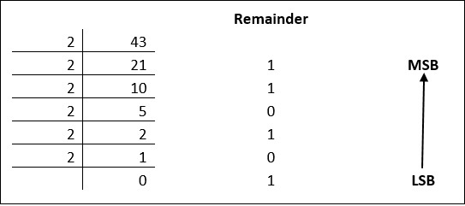
The remainders are to be read from bottom to top to obtain the binary equivalent.
43₁₀ = 101011₂

Decimal to Octal
Decimal numbers can be converted to octal by repeated division of the number by 8 while recording the remainder. Let’s take an example to see how this happens.
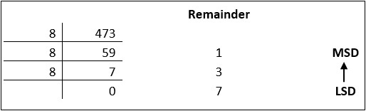
Reading the remainders from bottom to top,
473₁₀ = 731₈

Decimal to Hexadecimal
Decimal numbers can be converted to octal by repeated division of the number by 16 while recording the remainder. Let’s take an example to see how this happens.
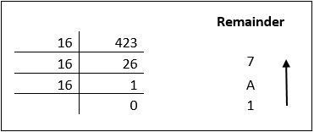
Reading the remainders from bottom to top we get,
423₁₀ = 1A7₁₆

Binary to Decimal
Convert 100111₂ into the decimal system.
Step 1: Identify the base of the given number. Here, the base of 100111₂ is 2.
Step 2: Multiply each digit of the given number, starting from the rightmost digit, with the exponents of the base. The exponents should start with 0 and increase by 1 every time as we move from right to left. Since the base is 2 here, we multiply the digits of the given number by 2⁰, 2¹, 2² , and so on from right to left.
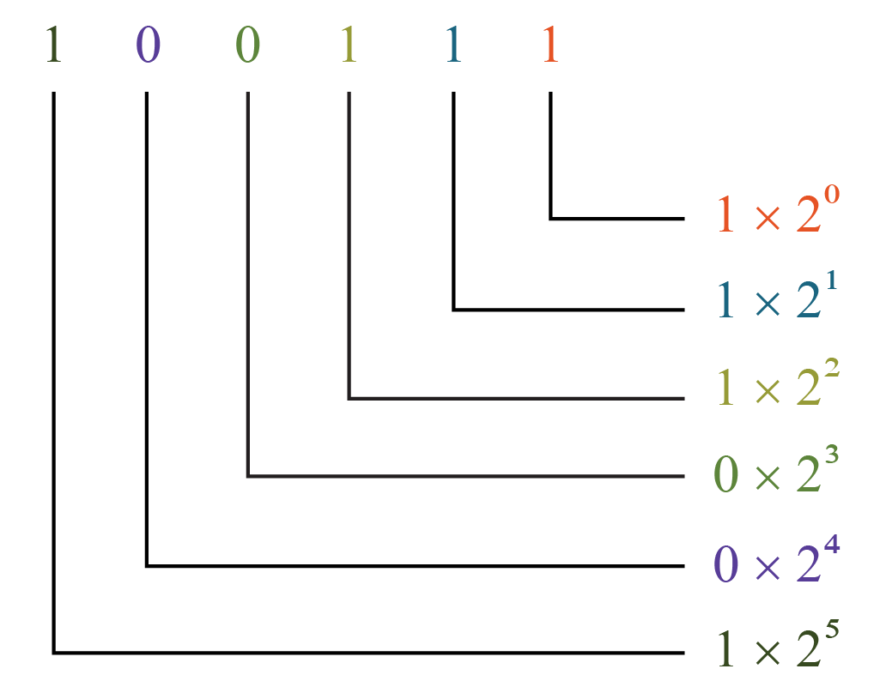
Step 3: We just simplify each of the above products and add them.
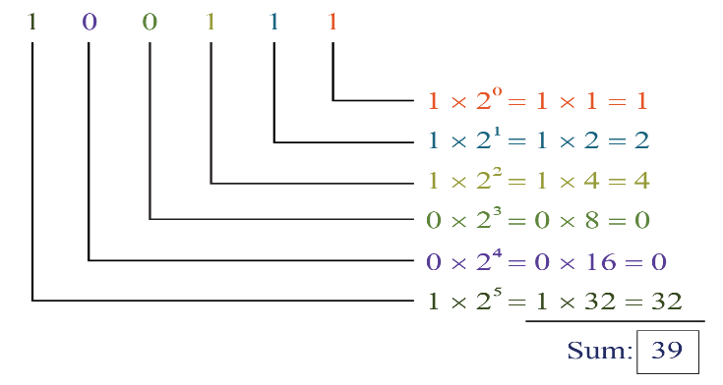
Here, the sum is the equivalent number in the decimal number system of the given number. Or, we can use the following steps to make this process simplified.
100111 = (1×2⁵) + (0×2⁴) + (0×2³) + (1×2²) + (1×2¹) + (1×2⁰)
= (1×32) + (0×16) + (0×8) + (1×4) + (1×2) + (1×1)
= 32 + 0 + 0 + 4 + 2 + 1
= 39
Thus, 100111₂ = 39₁₀.

Binary to Octal
To convert a binary number to octal number, these steps are followed −
- Starting from the least significant bit, make groups of three bits.
- If there are one or two bits less in making the groups, 0s can be added after the most significant bit
- Convert each group into its equivalent octal number
In the following three-digit binary numbers first place from the right represents the value “1” the second place represents the value “2” and third place represents the value “4”.
Binary Numbers | Octal Numbers
000 | 0
001 | 1
010 | 2
011 | 3
100 | 4
101 | 5
110 | 6
111 | 7
Let’s take an example to understand this.
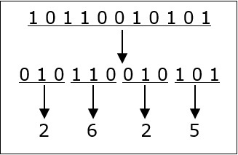
1011001010₁₂ = 2625₈

Binary to Hexadecimal
To convert a binary number to hexadecimal number, these steps are followed −
- Starting from the least significant bit, make groups of four bits.
- If there are one or two bits less in making the groups, 0s can be added after the most significant bit.
- Convert each group into its equivalent octal number.
In the following four-digit binary numbers first place from the right represents the value “1” the second place represents the value “2” the third place represents the value “4” and the fourth place represents the value “8”.
Binary Numbers | Hexadecimal Numbers
0000 | 0
0001 | 1
0010 | 2
0011 | 3
0100 | 4
0101 | 5
0110 | 6
0111 | 7
1000 | 8
1001 | 9
1010 | A
1011 | B
1100 | C
1101 | D
1110 | E
1111 | F
Let’s take an example to understand this.
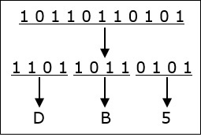
10110110101₂ = DB5₁₆.
Octal to Decimal
To convert an octal number to a decimal number we need to multiply each digit of the given octal with the reducing power of 8.
Let us learn here, the conversion of Octal number to Decimal Number or base 8 to base 10.

Examples on Octal to Decimal
Example 1: Suppose 215₈ is an octal number, then it’s decimal form will be,
215₈ = 2 × 8² + 1 × 8¹ + 5 × 8⁰
= 2 × 64+ 1 × 8 + 5 × 1 = 128 + 8 + 5
= 141₁₀
Example 2: Let 125 is an octal number denoted by 125₈. Find the decimal number.
125₈ = 1× 8² + 2 × 8¹ + 5 × 8⁰
= 1 × 64 + 2 × 8 + 5 × 1 = 64+16+5
=85₁₀
Octal to Binary
To convert an octal number to binary, each octal digit is converted to its 3-bit binary equivalent according to this table.
Octal Digit | 0 | 1 | 2 | 3 | 4 | 5 | 6 | 7
Binary Equivalent | 000 | 001 | 010 | 011 | 100 | 101 | 110 | 111
54673₈ = 101100110111011₂
Octal to Hexadecimal
Conversion of the octal number to hexadecimal requires two steps.
- First, convert octal numbers to decimal numbers.
- Then, convert decimal numbers to hexadecimal numbers.
Example
Let us understand with the help of an example. We will take the same example, where we have converted the octal numbers to decimal, such as;
(55)₈ = (45)₁₀
Now, convert (45)₁₀ into a hexadecimal number by dividing 45 by 16 until you get a remainder less than 16.
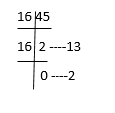
Therefore, we can write, (45)₁₀ = (2D)₁₆
Or (55)₈ = (2D)₁₆
Hexadecimal to Decimal
To convert a hexadecimal to a decimal manually, you must start by multiplying the hex number by 16. Then, you raise it to a power of 0 and increase that power by 1 each time according to the hexadecimal number equivalent.
We start from the right of the hexadecimal number and go to the left when applying the powers. Each time you multiply a number by 16, the power of 16 increases.
When converting a C9 hexadecimal to a decimal your work should look something like this:

Example 1
(C9)₁₆ = 12× 16¹ + 9 × 16⁰
= 12× 16 + 9 × 1
= 192 + 9
= 201₁₀
Hexadecimal to Binary
Convert A2B₁₆ to an equivalent binary number.
Given hexadecimal number = A2B₁₆
First, convert the given hexadecimal to the equivalent decimal number.
A2B₁₆ = (A × 16²) + (2 × 16¹) + (B × 16⁰)
= (A × 256) + (2 × 16) + (B × 1)
= (10 ×256) + 32 + 11
= 2560 + 43
= 2603(Decimal number)
Now we have to convert 2603₁₀ to binary
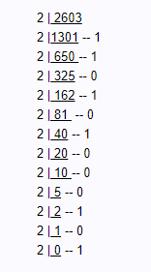
The binary number obtained is 101000101011₂
Hence, A2B₁₆ = 101000101011₂
Convert E₁₆ to an equivalent binary number.
Given, a hexadecimal number is E.
First, convert the given hexadecimal to the equivalent decimal number.
E₁₆ = E × 16⁰
= E × 1
= E
=14 (Decimal number)
Now we have to convert 14₁₀ to binary number.
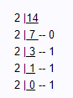
The binary number obtained is 1110₂
Hence, E₁₆ = 1110₂
Convert 30₁₆ to an equivalent binary number.
Given the hexadecimal number is 30
First, convert the given hexadecimal to the equivalent decimal number.
30₁₆ = (3 × 16¹) + (0 × 16⁰)
= 48 + 0
= 48(Decimal number)
Now we have to convert 48₁₀ to binary.
Therefore,
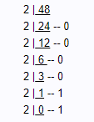
The binary number is 110000₂
Hence, 30₁₆ = 110000₂
Hexadecimal to Octal
Find the equivalent octal form of C1₁₆.
Given, a hexadecimal number is C1
C1₁₆ = (C × 16¹) + (1 × 16⁰)
= C × 16 + 1 × 1
=12 × 16 + 1
= 192 + 1
C1₁₆ =193 (Decimal form)
Now we have to convert this decimal to octal number;
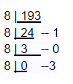
The octal number is 301₈
Hence, C1₁₆ = 301₈
Find the equivalent octal form of F₁₆.
Given, a hexadecimal number is F.
F₁₆ = (F × 16⁰)
= F × 1
= F
= 15(Decimal form)
Now we have to convert this decimal to equivalent octal number;
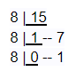
The octal number is 17₈
Hence, F₁₆ = 17₈
Find the equivalent octal form of 105₁₆
Given, a hexadecimal number is 105.
105₁₆ = (1 × 16²) + (0 × 16¹) + (5 × 16⁰)
= 1×256 + 0 × 16 + 5 × 1
=256 + 0 +5
= 261(Decimal form)
Now we have to convert this decimal to equivalent octal;
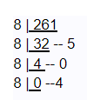
The octal number is 405₈
Hence, 105₁₆ = 405₈

